Assignment, Text Classification Task in NLP

(group assignment)

4 in 1 group

SUBMISSION DATE: 27FEB

Task: to classify text, this is multi-class classification.

1. Data will be provided
2. This is a workflow:

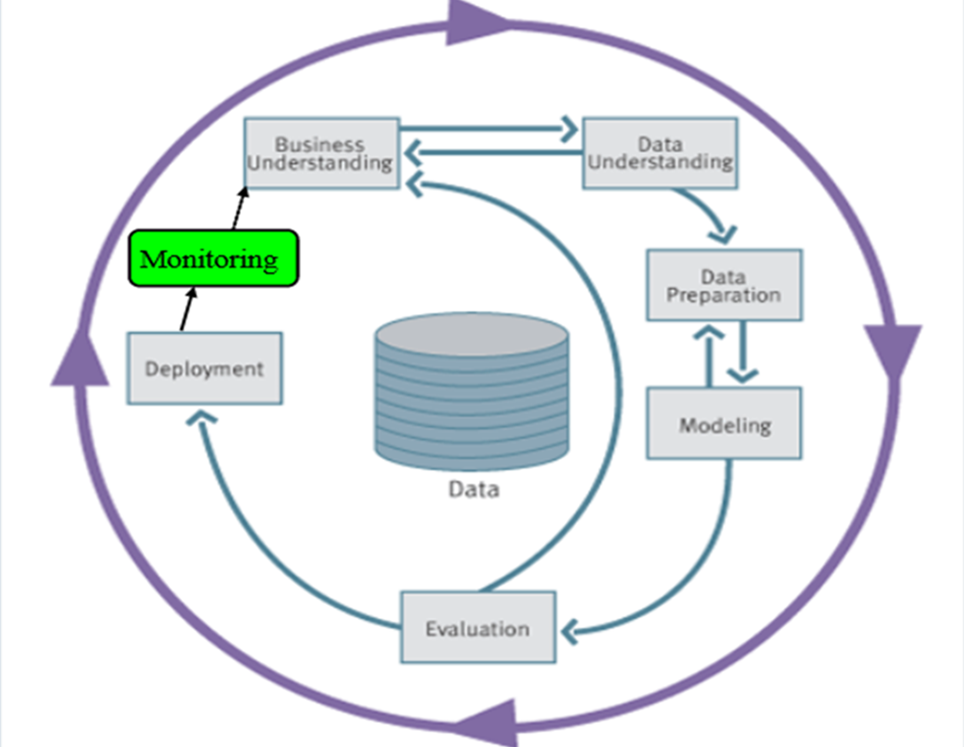

1. You cover data understanding (e.g, exploratory data analysis), data preparation (including data cleaning and feature extraction), modeling (try at least 3 models), evaluation and deployment.
2. Evaluation:
   1. Please evaluate for each category (of 18), based on evaluation metrics.
3. Deployment requirements:
   1. Minimum requirement. A simple GUI with 3 elements: text field, ‘classify’ button, and result field.

(more is welcome)

Deployment methods:

* 1. Option 1, flask application

(other presentation styles also welcome)

1. Grading criteria:

Accuracy + 5 (weight is 90%)

Presentation (weight 10%)

1. DO and DONTS:

You can use any Classification, Deep Learning or Gen AI algorithms/tools, but not paid ones.